Topic 4.11

STRUCTURE DETERMINATION

Mass Spectrometry
Nmr Spectroscopy
Chromatography

INTRODUCTION TO STRUCTURE DETERMINATION

There are so many organic compounds in existence that it can be difficult to establish exactly what compounds, or what combinations of compounds, are present in a given sample. Chemical tests can be used to distinguish between different functional groups, and melting point and boiling point data can provide some further information as to the identity and purity of a compound, but they can generally only confirm suspected structures and can not usually be used to identify new compounds. Chemical techniques also require fairly large quantities of sample and are not always effective at distinguishing between similar compounds.

Chemists have developed a number of other, more precise, analytical techniques to determine the exact structure of organic compounds. Knowledge of three of these techniques is required for AQA A-level Chemistry. These are mass spectrometry, infra-red spectroscopy and nuclear magnetic resonance (nmr) spectroscopy.

As infra-red spectroscopy is covered at AS-level, this topic is concerned with a more detailed consideration of mass spectrometry and nmr spectroscopy.

At A-level, these analytical techniques must be used to determine the structure of organic molecules containing carbon, hydrogen and oxygen only and generally containing no more than six carbon atoms. The molecule being analysed will be an alkane, alkene, alcohol, ether, carbonyl, carboxylic acid or ester.

Usually, information is given which enables the empirical formula to be deduced before the analysis begins. This is usually given in the form of composition by mass:

Eg A compound contains 40.0% carbon, 53.3% oxygen and 6.7% hydrogen.

Mole ratio: C 40/12 = 3.3
H 6.7/1 = 6.7
O 53.3/16 = 3.3

Simplest whole number ratio: C 3.3/3.3 = 1
H 6.7/3.3 = 2
O 3.3/3.3 = 1

So empirical formula = CH₂O

The molecular formula of the molecule, and its structure, can then be deduced from one or more of the analytical techniques.

MASS SPECTROMETRY

a) Introduction

The technique of mass spectrometry was used at AS-level to determine the relative abundances of different isotopes in a sample of an element, to deduce relative atomic masses and to deduce molecular formulae.

Mass spectrometry can also be used to determine the structure of organic molecules. In some respects molecules behave in a similar way to atoms in a mass spectrometer, but there are important differences:

When a molecule is ionised, one electron is removed. As molecules generally contain paired electrons only, the result is the formation of a species with an unpaired electron, or a free radical.

Eg ethane:
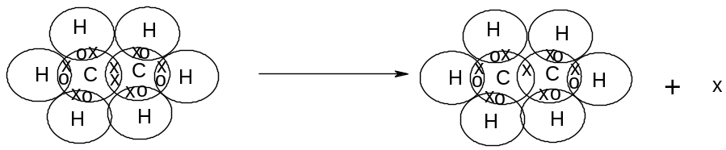

or C₂H₆ → [C₂H₆]^{+·} + e

The resulting species is thus a positively charged ion and also a free radical. It is known as the molecular ion (or parent ion).

Two possible things can happen to a molecular ion when it is formed:

- it can pass intact through the mass spectrometer and onto the detector, being detected as having an m/z ratio of which z = 1 and m = relative mass of molecular ion.

- it can break up into two smaller, more stable species, one of which is a positively charged ion and one is a free radical. This is known as fragmentation. This will result in the detection of species with m/z ratios which are less than that of the molecular ion.

The result is that a number of different peaks are seen in the mass spectrum of an organic molecule:

- the peak with the largest m/z ratio corresponds to the molecular ion, and this m/z ratio corresponds to the relative molecular mass of the molecule.

- the peaks with smaller m/z ratios result from fragmentation of the molecular ion. These peaks can be used to deduce more information regarding the structure of the molecule, because different molecules fragment in different ways and some fragments are more stable than others.

Eg mass spectrum of ethanol:

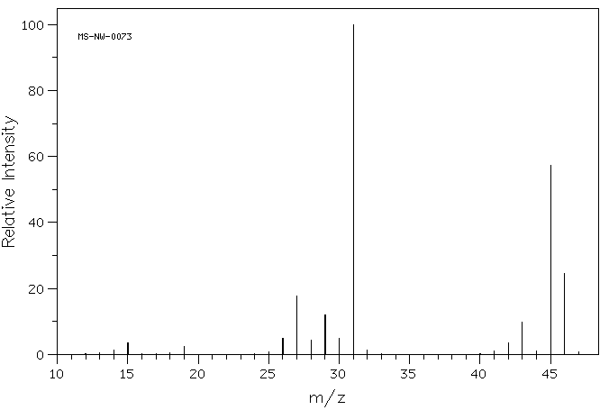
The mass spectrum of ethanol contains several peaks:

- the largest m/z ratio in the mass spectrum is 46. This is therefore the molecular ion peak which means that the molecule has a relative molecular mass of 46.
- the other peaks with smaller m/z ratios result from fragmentation of the ethanol molecule. The most abundant fragment ions appear to have relative masses of 45 and 31, and there are less abundant fragment ions with masses of 27 and 29

b) fragmentation

During fragmentation, the free radical molecular ion is broken up. As the molecular ion contains an odd number of electrons, one of the species into which it fragments will contain an even number of electrons (this will be a positive ion) and the other will contain an odd number of electrons (this will be a free radical).

Eg consider the case of ethane:

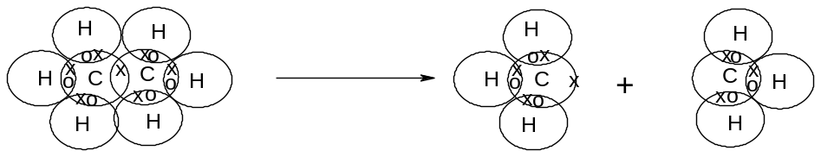
This is the free radical molecular ion | This species keeps the unpaired electron and is an uncharged free radical  (not detected in mass spectrometer) | This species loses the electron and is a positively charged ion  (detected in mass spectrometer)

This process can be represented by the equation:

[C₂H₆]^{+·} → [CH₃]· + [CH₃]⁺

Only the charged species is detected as the neutral free radical is neither accelerated nor deflected.

The process of fragmentation can thus be represented by the following general equation:

R^{+·} → X⁺ + Y·

R^{+·} is the molecular ion and is detected (assuming not all of them fragment)
X⁺ is the fragment ion and is detected
Y· is the fragment radical and is not detected

c) stable ions

Not all possible fragments are detected – some of the fragments form stable ions and these are more likely to be formed.

The most stable cations are carbocations (eg CH₃⁺, CH₃CH₂⁺ and CH₃CHCH₃⁺) and acylium ions (eg HCO⁺, CH₃CO⁺, CH₃CH₂CO⁺). These are thus the fragments most likely to be detected, and will give the most intense peaks in a mass spectrum.
The main peaks in the mass spectrum of an organic compound will thus be the molecular ion peak and the peaks corresponding to the most stable ions which can be formed from fragmentation of the molecular ion.

Eg butanone: CH₃CH₂COCH₃

Expected in the mass spectrum of butanone would be:

m/z ratio | Ion responsible | Equation to show formation of ion
72 | [CH₃CH₂COCH₃]^{+·}
15 | [CH₃]⁺ | [CH₃CH₂COCH₃]^{+·} → [CH₃]⁺ + [CH₂COCH₃]·
29 | [CH₃CH₂]⁺ | [CH₃CH₂COCH₃]^{+·} → [CH₃CH₂]⁺ + [COCH₃]·
57 | [CH₃CH₂CO]⁺ | [CH₃CH₂COCH₃]^{+·} → [CH₃CH₂CO]⁺ + [CH₃]·
43 | [COCH₃]⁺ | [CH₃CH₂COCH₃]^{+·} → [COCH₃]⁺ + [CH₃CH₂]·

The real mass spectrum of butanone is shown below:

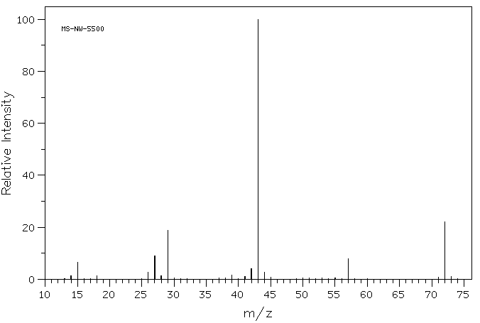
The most abundant peak is 43, followed by 72 and 29. The peaks at 15 and 57 can also be accounted for. (It is rarely possible to account for all the peaks in a mass spectrum)

d) using mass spectra to determine structure

The molecular ion peak enables the relative molecular mass of the compound to be deduced.

The other peaks give the masses, and hence the possible identities, of the fragments. These gives important clues to the structure of the unfragmented molecule.
Eg A peak at 29 suggests the presence of CH₃CH₂⁺
A peak at 43 suggests the presence of CH₃CH₂CH₂⁺, CH₃CHCH₃⁺ or CH₃CO⁺
A peak at 57 suggests the presence of CH₃CH₂CO⁺ or CH₃COCH₂⁺

The presence (or absence) of these fragments gives important information as to which structural features are present (or not present) in the molecule. This is particularly useful for distinguishing between isomers:

Eg C₄H₁₀ - butane gives peaks at 15, 29, 43 and 58
methylpropane gives peaks at 15, 43 and 58 only (no peak at 29)

Eg C₃H₆O - propanal gives peaks at 15, 29, 43 and 58
propanone gives peaks at 15, 43 and 58 only (no peak at 29)

Eg C₂H₆O - ethanol gives peaks at 15, 29 and 46
Methoxymethane gives peaks at 15 and 46 (no peak at 29)

Thus the presence (or absence) of specific fragments enables the structure to be determined.
N.M.R SPECTROSCOPY

a) Introduction

Some nuclei have magnetic properties. If these nuclei are subjected to a strong magnetic field, they can either align themselves in the same direction as the magnetic field (a low-energy state) or in the opposite direction (a high-energy state). When these nuclei are then subjected to radio waves with a range of frequencies, each nucleus can absorb the frequency which corresponds to the difference in energy between its low-energy state and its high-energy state and switch from one to the other. The absorption can be detected and converted into a spectrum. The frequency of the radiation absorbed by the nuclei varies depending on the type of nucleus and the arrangement of electrons around that nucleus, and can thus be used to provide important structural information about the molecule. This technique for structure determination is known as nuclear magnetic resonance (nmr) spectroscopy.

There are a number of different types of nmr spectroscopy, depending on the type of nucleus being investigated. Two techniques are required at A-level:

- proton nmr spectroscopy investigates the absorption of radiation by nuclei of hydrogen atoms (¹H) and is thus a technique for obtaining information about the number and arrangement of hydrogen atoms in a molecule
- carbon-13 nmr spectroscopy investigates the absorption of radiation by nuclei of carbon-13 atoms (¹³C) and is thus a technique for obtaining information about the number and arrangement of carbon atoms in a molecule

b) proton nmr spectroscopy

A number of important pieces of information can be deduced from analysis of a proton nmr spectrum:

- Identical hydrogen atoms all absorb radiation at the same frequency and so contribute to the same peak. The number of different peaks, therefore, tells you the number of different environments of hydrogen atoms in the molecule.

- The area under each peak is related to the intensity of the absorption and gives information about the number of hydrogen atoms of that type in the molecule. The relative intensity of the peaks is known as the integration factor and is generally given as a simplest whole number ratio (as it is not always easy to see from the spectrum)

- The frequency of the radiation absorbed depends on the environment of the hydrogen atom and gives information about the position of those hydrogen atoms in the molecule relative to other carbon atoms and functional groups. The actual frequency of the absorption is difficult to measure; instead the frequency is measured relative to a standard. What is measured is the difference between the frequency absorbed by the sample atoms and the frequency absorbed by the standard, expressed as a fraction of the frequency absorbed by the standard. This fraction is known as the chemical shift and is given the symbol δ.
δ = f(sample) – f(standard)
f(standard)
The value of δ is generally very small; typically 1-10 x 10⁻⁶. It is therefore expressed in parts per million – ie 2.0 x 10⁻⁶ is equivalent to 2.0 ppm. The chemical shift is generally greater if the hydrogen atoms are closer to electronegative atoms, but is also relatively high for hydrogen atoms close to alkene and arene groups. Hydrogen atoms with a large chemical shift are said to be deshielded, and hydrogen atoms with a low chemical shift are said to be shielded. The peak resulting from the standard always has (by definition) a chemical shift of zero.

- The peaks are often not single peaks; they are split into a number of peaks very close together. The way in which each peak is split depends on the total number of hydrogen atoms on adjacent atoms. The level of splitting of the peaks is given by (n+1), where n = number of hydrogen atoms on adjacent atoms. A hydrogen atom with no hydrogen atoms on adjacent carbon atoms will have no splitting and will give a single peak known as a singlet. If n = 1 the peak will be split once and will thus appear as a doublet. The names of the split peaks are as follows:

 | Value of n | Type of peak
 | 0 | Singlet
 | 1 | Doublet
 | 2 | Triplet
 | 3 | Quartet
 | 4 | Quintet
 | 5 | Sextet
 | 6 | Septet

The splitting of the peaks by adjacent hydrogen atoms in this way is known as coupling. If a hydrogen atom is involved in hydrogen bonding, its peak will never be split (it will always be a singlet) and it will not contribute to the splitting of any other peaks.

A typical proton nmr spectrum looks like this:

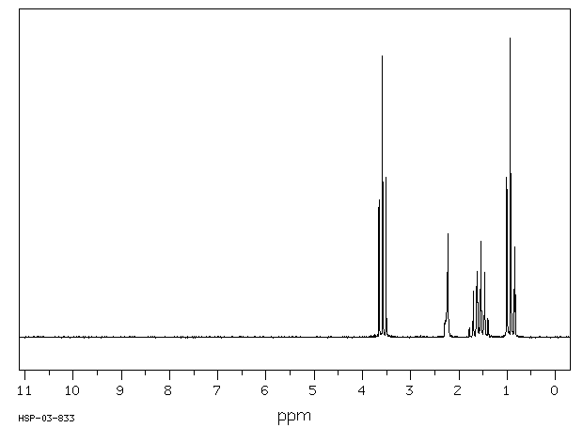

From this spectrum, it is clear that there are four peaks. The chemical shift can be read from the horizontal axis, and the integration factor and splitting can be deduced by looking at the size and shape of the peaks (computer techniques are usually required to work out the integration factor). The four peaks in the above spectra could be described as follows:

Chemical shift/ppm | Splitting | Integration Factor
0.9 | triplet | 3
1.6 | sextet | 2
2.3 | singlet | 1
3.7 | triplet | 2

The chemical shift, splitting and integration factor can all be used to deduce important information about the structure of the molecule in the sample.

Note that the integration factor (the area under peak) is difficult to read directly. For this reason, the integration factor is indicated above the peak. Alternatively, pre-integrated nmr spectra are often used. The line above the spectrum shifts vertically when it passes each peak. The magnitude of the vertical shift is proportional to the integration factor of each peak. One example, showing both the integration line and the integration factor is shown below:

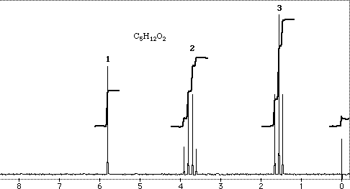

The shifts at each peak are in the ratio 1:2:3, and this ratio is the integration factor. You will need to deduce the integration factor of each peak using only the integration line.
c) carbon-13 nmr spectroscopy

Carbon-13 nmr spectroscopy works in a similar way to proton nmr spectroscopy, but it is much simpler:

- Identical carbon atoms all absorb radiation at the same frequency and so contribute to the same peak. The number of different peaks, therefore, tells you the number of different environments of carbon atoms in the molecule.

- The area under the peaks does not correspond exactly to the intensity of the absorptions, so it is not possible to conclude the number of carbon atoms present in each environment.

- The frequency of the radiation absorbed depends on the environment of the carbon atom and gives information about the position of those carbon atoms in the molecule relative to other atoms and functional groups. This is measured in the same way as in proton nmr spectra, using chemical shift.

- Peaks in the carbon-13 nmr spectrum are not split, so it is not possible to deduce information about the number of adjacent carbon atoms in each carbon environment

A typical carbon-13 nmr spectrum looks like this:

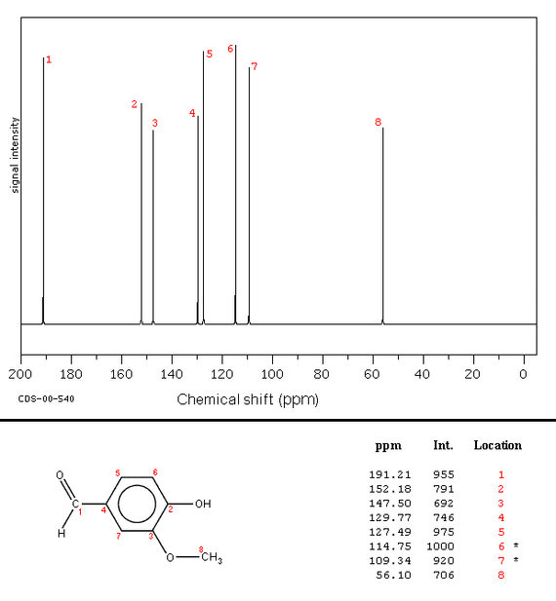

From this spectrum, it is clear that there are eight peaks. This means that there are eight different types of carbon atom in the molecule, each with a different chemical shift.

c) Preparing samples for proton nmr analysis

Before a spectrum can be analysed, it is necessary to produce a spectrum and preparing a sample for proton nmr analysis requires some consideration:

i) Choosing a suitable solvent

It is necessary to dissolve the sample in a solvent before it can be analysed. The problem with most solvents is that they themselves contain hydrogen atoms which absorb radiation, interfering with the spectrum produced by the sample. It is therefore necessary to use a solvent which contains no hydrogen atoms. The usual choices are CCl₄ and CDCl₃. D is the symbol for deuterium; this is an isotope of hydrogen containing one neutron in its nucleus. It has no magnetic properties and does not interfere with a proton nmr spectrum.

ii) Choosing a standard

In addition to the solvent, a standard (or reference) molecule must be added to calibrate the spectrum. The chemical shift is then measured relative to this standard as described above. The standard normally used is tetramethylsilane (T.M.S.) which has the following structure:
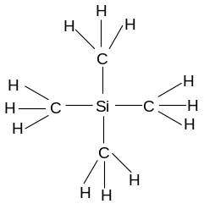
This substance has a number of advantages as a standard:

- It produces a single, singlet peak which is very intense (there are 12 H atoms, all identical) which makes the peak easy to identify.

- The H atoms are highly shielded (as the Si is an electropositive atom, releasing electron density onto the H atoms) so the peak is generally at a significantly lower frequency than that found in most organic molecules, meaning that it does not interfere with the other peaks and can be easily distinguished from them.

- It is cheap and non-toxic.

The large singlet which arises in proton nmr spectra at δ = 0 as a result of the TMS standard is usually erased from the spectra before it is produced (so you never see it).

d) Using proton nmr spectra in structure determination

Proton nmr spectra are very useful for working out the structure of organic molecules, particularly if the molecular formula is known. The information from a spectrum can be broken down into four parts:

i) the number of peaks

Each peak corresponds to one set of identical hydrogen atoms. The number of peaks therefore gives the number of types of hydrogen atom present.

In some molecules, all the hydrogen atoms are identical. These molecules give only one peak in the spectrum.
Eg ethane, propanone, methoxymethane
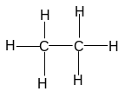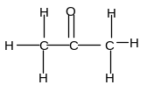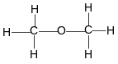
In some molecules, there are two types of hydrogen atom. These molecules will give two peaks in a proton nmr spectrum.
Eg butane, pentan-3-one, ethanal, methanol
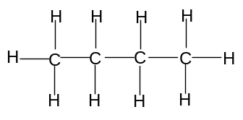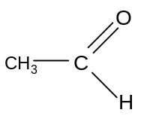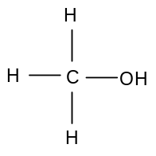

Most molecules, however, give more than two peaks:

Butanone gives three peaks:
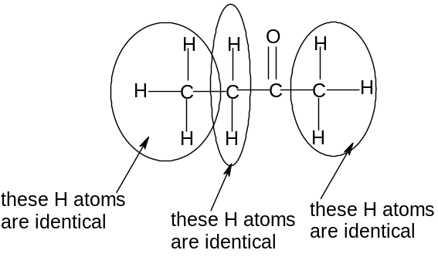

Butanal gives four peaks: Ethanol gives three peaks:

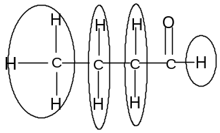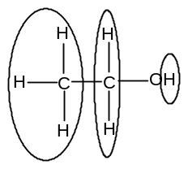

Each of the H atoms within the same circle are identical and contribute towards the same peak.

Methylpropanal gives three peaks:

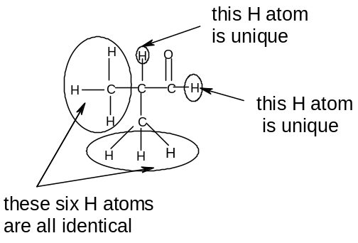
ii) integration factor

The integration factor indicates the number of identical hydrogen atoms corresponding to that peak. Molecules which give the same number of peaks can be distinguished because the integration factor of each peak is different, corresponding to a different distribution of H atoms in the molecule.

Eg. Methylpropanal and butanone (C₄H₈O) both give three peaks in their proton nmr spectra:
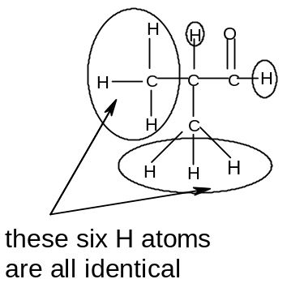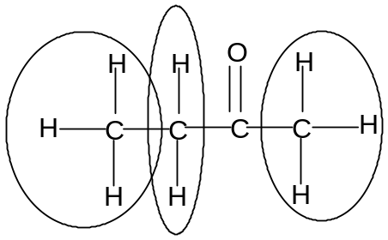

However the integration factors of the three peaks in methylpropanal will be 6:1:1, but in butanone they will be 3:3:2. The two molecules can thus be distinguished by their proton nmr spectra because the integration factors of the peaks are different.

iii) chemical shift

The chemical shift depends on the environment around the H atom; in particular it is related to the proximity of electronegative atoms. The nearer a hydrogen atom is to an electronegative atom, the more deshielded it will be and the greater the chemical shift.
For example, H atoms in alkanes tend to have low chemical shifts (δ= 0 - 2), but H atoms attached to O atoms in carboxylic acids tend to have high chemical shifts (= 10-12).

All H atoms not within one carbon atom of a functional group will have a chemical shift between 0 and 2 ppm.

The following table summarises the important chemical shifts for H atoms in common environments close to a functional group:

environment | Type of molecule | Chemical shift/ppm
H-C-C=O | carbonyl | 2.0 – 2.5
H-C-O | alcohol or ether | 3.3 – 4.0
O-H | alcohol | 0.5 – 5.0
H-C=C | alkene | 4.6 – 5.9
H-C=O | aldehyde | 9 - 10
O-H | acid | 10 - 12

The chemical shift data provides useful information in deducing the environments responsible for a particular peak and identifying functional groups:

Consider the proton nmr spectra of two unknown compounds:

1.
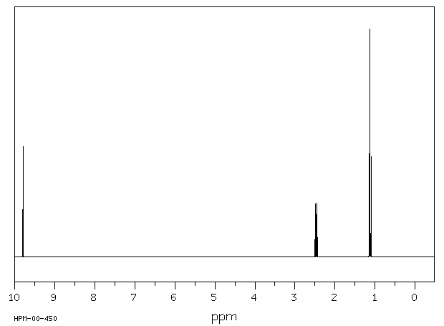

The peak at δ = 9.7 suggests an H atom in an aldehyde group.
The peak at δ = 2.5 suggests H atoms on a C adjacent to a carbonyl group
The peak at δ = 1.1 suggests H atoms on a C not adjacent to a functional group

Integration factors (1 for δ = 9.7, 2 for δ = 2.5, 3 for δ = 1.1) would suggest propanal:
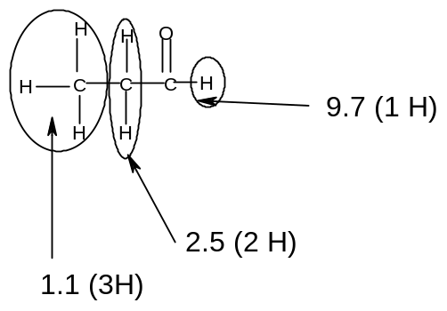
2.
The peak at δ = 3.6 suggests an H atom on a C adjacent to a C-O bond
The peak at δ = 2.3 suggests H atoms on a C adjacent to a carbonyl group, but as this is inconsistent with the structure it could also suggest an H atom bonded to O in an alcohol
The peak at δ = 1.6 suggests H atoms on a C not adjacent to a functional group
The peak at δ = 0.9 suggests H atoms on a C not adjacent to a functional group
Integration factors (2 for δ = 3.6, 1 for δ = 2.3, 2 for δ = 1.6 and 3 for δ = 0.9) would suggest propan-1-ol:
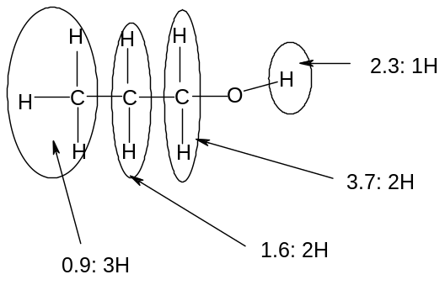

Chemical shift data is thus useful for identifying functional groups and for deducing the position of other H atoms on the molecule.

iv) coupling

As was discussed earlier, the absorption of radiation by hydrogen atoms is affected by the presence of hydrogen atoms on adjacent carbon atoms (provided they are not involved in hydrogen bonding). These hydrogen atoms on adjacent carbon atoms cause a splitting of the peak according to the (n+1) rule as described earlier.

This is very useful for positioning the hydrogen atoms in different environments relative to each other.

Consider a CH₃- group. This will account for a peak with integration factor 3.
The splitting of this peak, however, will depend on the hydrogen atoms on the adjacent carbon atom:

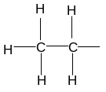 Here n = 2 so a triplet will be observed

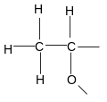or 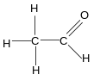 Here n = 1 so a doublet will be observed
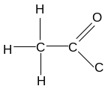 or 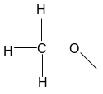 Here n = 0 so a singlet will be observed

Consider a -CH₂- group. This will account for a peak with integration factor 2.

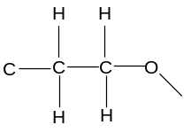 or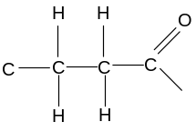 Here n = 2 so a triplet will be observed

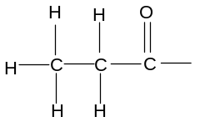or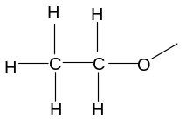 Here n = 3 so a quartet will be observed

Thus the splitting of the peaks gives much useful information about the splitting patterns in the molecule.

Eg Consider the following proton nmr spectrum:
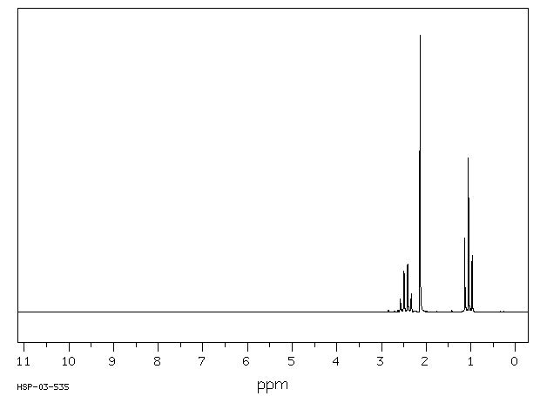
The peak at δ = 1.0 is a triplet (2 H atoms on adjacent carbons), with integration factor 3.
- this suggests that it is caused by a CH₃- group adjacent to a -CH₂- group
The peak at δ = 2.4 is a singlet (0 H atoms on adjacent carbons), with integration factor 3.
- this suggests that it is caused by a CH₃- group attached to -O- or –C=O
- but if it were attached to -O- it would have a chemical shift of 3.3 – 4.0
- so it is probably caused by a CH₃ group attached to –C=O
The peak at δ = 2.1 is a quartet (3 H atoms on adjacent carbons), with integration factor 2.
- this suggests that it is caused by a -CH₂- group attached as CH₃-CH₂-C=O or
CH₃-CH₂-O-
- but if it were attached to -O- it would have a chemical shift of 3.3 – 4.0
- so it is probably caused by CH₃-CH₂-C=O

So the molecule is butanone:
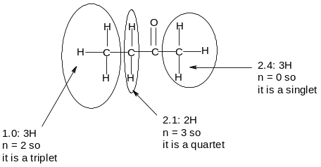
Hydrogen bonded atoms do not contribute to coupling:

Eg consider the proton nmr spectrum of ethanol:

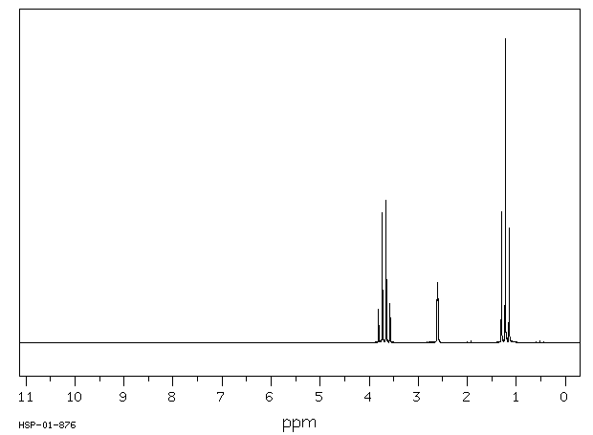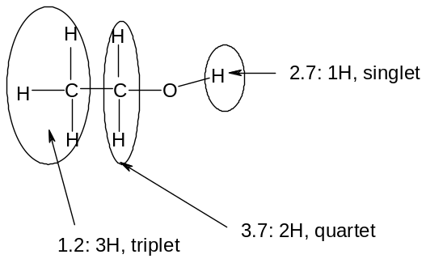

The peak at δ = 1.2 is a triplet, with integration factor 3. It is the –CH₃ bonded to the -CH₂-.

The peak at δ = 3.7 is a quartet. It is the –CH₂- bonded to the –CH₃. It does not couple with the H attached to the O, even though it is on an adjacent carbon atom, because this H atom is involved in hydrogen bonding.

The peak at δ = 2.7 is a singlet, with integration factor 1. It is the H bonded to the O. It does not couple with the two –CH₂- hydrogen atoms because it is involved in hydrogen bonding.

Two important general points in particular should be noted:

- If a triplet with integration factor 3 and chemical shift 0 - 2 is present, as well as a quartet with integration factor 2, then CH₃CH₂- is almost certainly present
- Singlet peaks with integration factor 1 strongly suggest that an O-H bond is present

e) Using carbon-13 nmr spectra in structure determination

Carbon-13 nmr spectra are also useful for working out the structure of organic molecules, particularly if the molecular formula is known. However they give less information about a molecule than proton nmr spectra.

i) the number of peaks

Each peak corresponds to one set of identical carbon atoms. The number of peaks therefore gives the number of types of carbon atom present.

In some molecules, all the carbon atoms are identical. These molecules give only one peak in the spectrum.
Eg ethane, methoxymethane, cyclohexane, benzene

methoxymethane

Most organic molecules, however, give two or more peaks as at least some of the carbon atoms are not identical:

Propane and butane give two peaks. Pentane and hexane give three peaks.

Propene gives three peaks. But-2-ene gives two peaks. But-1-ene gives four peaks.

ii) chemical shift

The chemical shift depends on the environment around the carbon atom; in particular it is related to the proximity of electronegative atoms. The nearer a carbon atom is to an electronegative atom, the more deshielded it will be and the greater the chemical shift.
For example, carbon atoms in alkanes tend to have low chemical shifts (δ = 0 - 40), but carbon atoms attached to O atoms with a double bond tend to have high chemical shifts (δ = 160 - 220).

All carbon atoms not directly attached a functional group (ie singly bonded to only carbon or hydrogen atoms) will have a chemical shift between 0 and 40 ppm). The nearer an electronegative atom, the higher the chemical shift

The following table summarises the important chemical shifts for H atoms in common environments close to a functional group:

environment | Type of molecule | Chemical shift/ppm
-C-O- | alcohol, ether, ester | 50 - 90
-C=C- | alkene, arene | 90 - 150
-C=O | carboxylic acid, ester | 160 - 190
H-C=C | Aldehyde, ketone | 190 - 220

Eg consider the following carbon nmr spectrum of an alcohol with molecular formula C₄H₁₀O:

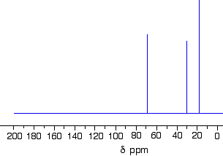

The spectrum gives three peaks, so there must be three different carbon atoms. As there are four carbon atoms in the molecule, two of them must be identical.

Of the possible isomers of C₄H₁₀O:
Butan-1-ol and butan-2-ol would give four peaks (all four C atoms are different)
Methylpropan-1-ol would give three peaks (two of the C atoms are identical)
Methylpropan-2-ol would give two peaks (three of the C atoms are identical)
The spectrum is therefore most likely to come from methylpropan-1-ol.
USING THE ANALYTICAL TECHNIQUES TOGETHER

If all the different spectra are available, then the most effective analytical strategy is to use them together. There are a number of useful steps to deducing the structure:

If composition data is available:

1. Use the composition data to work out the empirical formula.
2. Use the mass spectrum to deduce the relative molecular mass, and hence work out the molecular formula.
3. Use the infra-red spectrum to check for the presence of C=O and O-H bonds, and hence identify the functional group.
4. Make a list of the possible isomers consistent with the molecular formula and functional group.
5. Use the number of peaks in the proton nmr spectrum to deduce the number of hydrogen environments. Eliminate the isomers inconsistent with this number.
6. Use the integration factors in the proton nmr spectrum to work out the number of hydrogen atoms in each environment. Eliminate the isomers inconsistent with this distribution.
7. Compare the splitting of the peaks in the nmr spectrum with the expected splitting patterns of the remaining possible isomers. Eliminate the isomers which do not give this splitting pattern.
8. If necessary, compare the chemical shifts of the peaks in the nmr spectrum with the expected values. Eliminate the isomers which are inconsistent with the chemical shifts.

If composition data is not available, the molecular formula must be found by a trial and error method.

1. Deduce the relative molecular mass from the mass spectrum.
2. Deduce the functional groups present from the infra-red spectrum and hence establish the likely number of oxygen atoms present.
3. Add up the integration factors in the proton nmr spectra. The number of hydrogen atoms present is an integral multiple of this number.
4. Use the relative molecular mass and the information on hydrogen and oxygen atoms to deduce the molecular formula.

A worked example of combined analysis is given on the following page (no composition data available).
Use the following spectra to deduce the structure of A:

Mass spectrum: Proton nmr spectrum:
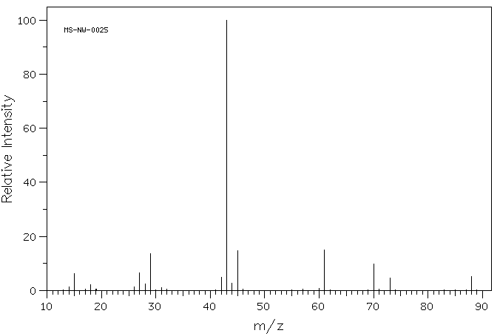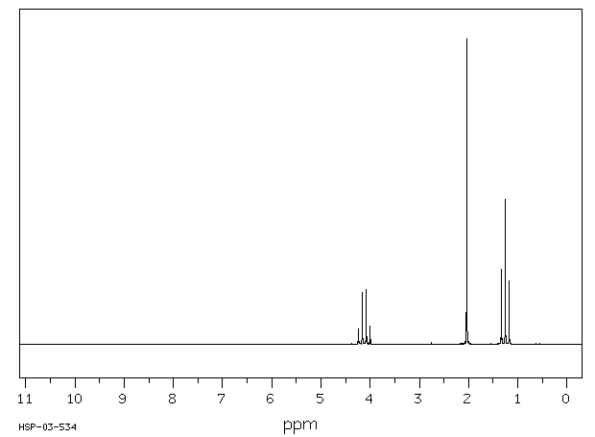
Molecular ion peak = 88 three peaks:
Most intense fragments: 43, 29, 45, 61, 70 δ = 1.3, triplet, integration factor 3
δ = 2.0, singlet, integration factor 3
δ = 4.1, quartet, integration factor 2

Infra-red spectrum: sharp absorption at 1715 cm⁻¹, no broad absorptions between 1500 and 3500 cm⁻¹

ANSWER:

From mass spectrum, rmm = 88
From infra-red spectrum, C=O present
From proton nmr spectrum, sum of integration factors = 8
So 8, 16 or 24 hydrogen atoms present and at least one oxygen
If one O atom present, remaining mass = 62 and cannot make this using 8/16/24 H atoms
If two O atoms present, remaining mass = 56; can make this from 4 carbons and H hydrogens
So likely molecular formula = C₄H₈O₂.

From infra-red spectrum, no O-H is present, so it is not a carboxylic acid.
So is probably an ester.
Possible structures:
Methyl propanoate, ethyl ethanoate, propyl methanoate, methylethyl methanoate

From proton nmr spectrum:
There are 3 hydrogen environments so it cannot be propyl methanoate (which has 4).
The integration factors are 3:3:2 so cannot be methylethyl methanoate (which has the ratio 6:1:1).
The coupling (3H triplet, 2H quartet, 3H singlet) is consistent with both remaining possible structures.

But the 3H singlet has a chemical shift of 2.0, which is consistent with CH₃CO and not CH₃O (for which the chemical shift would be 3.3 – 4.0)
The 2H quartet has a chemical shift of 4.1, which is consistent with CH₃CH₂O and not CH₃CH₂CO (for which the chemical shift would be 2.0 – 2.5)
So it cannot by methyl propanoate and therefore the structure is ethyl ethanoate.
Full explanation of spectra:

Infra-red spectrum:
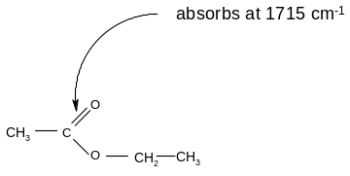
Proton nmr spectrum:
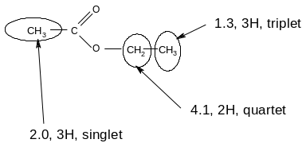
Mass spectrum:
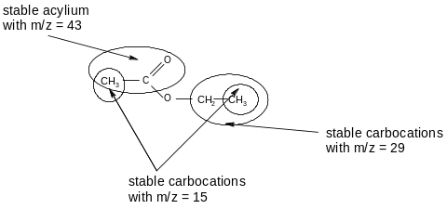
[CH₃COOCH₂CH₃]^{+·} is the molecular ion peak
[CH₃COOCH₂CH₃]^{+·} → [CH₃CO]⁺ + [OCH₂CH₃]· accounts for the peak at m/z = 43
[CH₃COOCH₂CH₃]^{+·} → [CH₃CH₂]⁺ + [CH₃COO]· accounts for the peak at m/z = 29
[CH₃COOCH₂CH₃]^{+·} → [CH₃]⁺ + [CH₃COOCH₂]· accounts for the peak at m/z = 15
[CH₃COOCH₂CH₃]^{+·} → [CH₃]⁺ + [COOCH₂CH₃]· accounts for the peak at m/z = 15
CHROMATOGRAPHY

Chromatography is a technique by which different compounds in a mixture can be separated and then analysed. There are two main types of chromatography:

- thin-layer chromatography
In thin-layer chromatography a liquid solvent is allowed to flow up a piece of chromatography paper or a TLC plate. The mixture is placed in a small area on the paper and allowed to flow up the paper with the solvent. Different substances move at different speeds, and the distance travelled by that substance compared to the solvent can be used to identify the substance.

- gas-liquid chromatography
In gas-liquid chromatography a gaseous mixture is allowed to flow through a column lined with a solid. Volatile liquids can also be vaporised and then allowed to flow through the column. Different gases take different amounts of time to flow through the column, and this can be used to identify the gas (or volatile liquid)

The mixture of substances moving through the column (or up the plate) is called the mobile phase. The substance lining the column (or the plate) is known as the stationary phase.

The speed at which each substance moves through the column or up the plate depends on its relative solubility in the two phases.

In gas-liquid chromatography, a substance that is strongly attracted to the stationary phase will move slowly through the column and take a long time to pass through the column. A substance which is not strongly attracted to the stationary phase will move more quickly through the column and take less time to pass through the column.

